Tutorial – 9

- Design an application which will demonstrate the operations like Insert, Update and Delete on data

using System;
using System.Collections.Generic;
using System.ComponentModel;
using System.Data;
using System.Data.SqlClient;
using System.Drawing;
using System.Linq;
using System.Text;
using System.Threading.Tasks;
using System.Windows.Forms;
using System.Xml.Linq;

namespace Tutorial_9
{
public partial class Form1 : Form
{
string connectionString = "Data Source=(localdb)\\MSSQLLocalDB;Initial Catalog=demo;Integrated Security=True;Connect Timeout=30;Encrypt=False;Trusted_Connection = True";
public Form1()
{
InitializeComponent();
}

private void button1_Click(object sender, EventArgs e)
{
SqlConnection con = new SqlConnection(connectionString);
SqlCommand cmd = new SqlCommand("SELECT * FROM student", con);
SqlDataAdapter da = new SqlDataAdapter(cmd);
DataTable dt = new DataTable();
da.Fill(dt);
dataGridView1.DataSource = dt;
}

private void button2_Click(object sender, EventArgs e)
{
SqlConnection con = new SqlConnection(connectionString);

con.Open();

string query = "insert into student values('" + textBox1.Text + "','" + textBox2.Text + "','" + textBox3.Text + "', '" + textBox4.Text + "','" + Convert.ToInt64(textBox5.Text) + "')";

SqlCommand cmd = new SqlCommand(query, con);
cmd.ExecuteNonQuery();

con.Close();
MessageBox.Show("Record Inserted Successfully");
}

private void button3_Click(object sender, EventArgs e)
{
textBox1.Clear();
textBox2.Clear();
textBox3.Clear();
textBox4.Clear();
textBox5.Clear();

}

private void button4_Click(object sender, EventArgs e)
{
if (dataGridView1.CurrentRow == null)
{
MessageBox.Show("Please select a row to update!");
return;
}

int id = Convert.ToInt32(dataGridView1.CurrentRow.Cells["id"].Value);

SqlConnection con = new SqlConnection(connectionString);
con.Open();

string query = ("UPDATE student SET " +
"name = '" + textBox1.Text + "', " +
"course = '" + textBox2.Text + "', " +
"dob = '" + textBox3.Text + "', " +
"address = '" + textBox4.Text + "', " +
"contact = '" + Convert.ToInt64(textBox5.Text) + "' " +

"WHERE id = " + id);
SqlCommand cmd = new SqlCommand(query, con);
cmd.ExecuteNonQuery();
con.Close();

MessageBox.Show("Record Updated Successfully");
}

private void button5_Click(object sender, EventArgs e)
{
if (dataGridView1.CurrentRow == null)
{
MessageBox.Show("Please select a row to delete!");
return;
}

int id = Convert.ToInt32(dataGridView1.CurrentRow.Cells["id"].Value);

SqlConnection con = new SqlConnection(connectionString);
con.Open();
string query = "DELETE FROM student WHERE id = " + id;
SqlCommand cmd = new SqlCommand(query, con);
cmd.ExecuteNonQuery();
con.Close();

MessageBox.Show("Record Deleted Successfully");
}

private void dataGridView1_CellContentClick(object sender, DataGridViewCellEventArgs e)
{
if (e.RowIndex >= 0)
{
DataGridViewRow row = dataGridView1.Rows[e.RowIndex];
textBox1.Text = row.Cells["name"].Value.ToString();
textBox2.Text = row.Cells["course"].Value.ToString();
textBox3.Text = row.Cells["dob"].Value.ToString();
textBox4.Text = row.Cells["address"].Value.ToString();
textBox5.Text = row.Cells["contact"].Value.ToString();
}
}
}
}

Output:
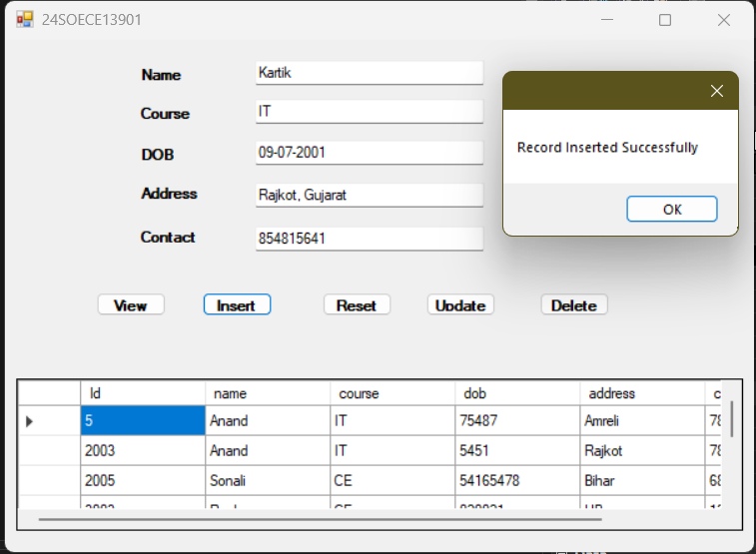

- Design an application which provide the search facility from database records
Using DataGridVeiw component.

using System;
using System.Collections.Generic;
using System.ComponentModel;
using System.Data;
using System.Data.SqlClient;
using System.Drawing;
using System.Linq;
using System.Text;
using System.Threading.Tasks;
using System.Windows.Forms;
namespace Tutorial_9
{
public partial class Form2 : Form
{
string connectionString = "Data Source=(localdb)\\MSSQLLocalDB;Initial Catalog=demo;Integrated Security=True;Connect Timeout=30;Encrypt=False;Trusted_Connection = True";
public Form2()
{
InitializeComponent();
}
private void button1_Click(object sender, EventArgs e)
{
SqlConnection conn = new SqlConnection(connectionString);
conn.Open();
SqlCommand cmd = new SqlCommand("SELECT * FROM search WHERE name LIKE @name", conn);
cmd.Parameters.AddWithValue("@name", "%" + textBox1.Text + "%");

SqlDataAdapter da = new SqlDataAdapter(cmd);
DataTable dt = new DataTable();
da.Fill(dt);
dataGridView1.DataSource = dt;
conn.Close();

}
}
}

Output:
